AIS 2017: Beyond Talking Heads

University of Maryland, Baltimore County

In 2017, the Association of Interdisciplinary Studies (AIS) annual conference is themed “Beyond talking heads: applied and experiential learning through an interdisciplinary lens.” Within this theme, we encourage workshops, presentations, and performances that explore interdisciplinary approaches to project-based learning on (and off) college campuses. Within this theme, our four, interrelated areas of focus are:
- Defining, executing and assessing project-based learning: Using project based learning to address complex problems, adapting existing initiatives such as NAE’s Grand Challenges for Engineering, and assessing student learning outcomes from applied learning.
- Adding value through the scholarship of interdisciplinarity (SOI): Facilitating meaningful connections between disciplinary perspectives, and making integrative strategies such as common ground and bridging strategies explicit in the learning process.
- Integrating the arts into other disciplines: analyses of projects such as arts integrated STEM (STEAM) initiatives and conflict resolution through theatre that create “added value.”
- Articulating the role of interdisciplinary studies programs within the evolving ecosystem of traditional disciplines, applied fields, and emerging interdisciplines on a contemporary college campus, including the analogous and corresponding challenges for creating, sustaining and assessing collaborations among faculty, professional staff and professionals of practice.
Beyond these major areas, our AIS conference is broad and inclusive. We welcome presentations on a wide range of activities related to interdisciplinary education and research. This includes presentations that examine the role of the academy in fostering interdisciplinary collaborations.
The conference will present four types of sessions, described below. All submissions must be made electronically using the proposal submission form on the 2017 Conference website, ais-2017.umbc.edu. The following are required for all submissions: contact information for presenters and co-presenters, proposal title (20 words or less), short description of no more than 50 words, an abstract of no more than 250 words, relevant keywords, and the type of presentation (Hermes presentation, Athena panel, Hephaestus workshop or Odysseus experience). For further information, contact ais-2017@umbc.edu.
Please note: if you are a current graduate student (verification of student status is required), you are eligible for up to $200 in travel funds if your proposal is accepted. Up to 10 such awards may be granted on a first come, first served basis. Please contact AIS Office Manager Shaunda Mankowski (mankowski@oakland.edu) for more information as soon as you have received your notice of acceptance.
As always, AIS welcomes more general presentations that advance its mission to promote the interchange of ideas among scholars, administrators and practitioners in all of the arts and sciences on intellectual and organizational issues related to advancing interdisciplinary studies.
The submission deadline is April 15, 2017, with responses anticipated by June 5, 2017.
For further information, please contact ais_2017@umbc.edu.

To help us move “beyond talking heads”, AIS 2017 asks presenters to align themselves with one of four session types:
 | Hermes Presentations: 20 minute, single person presentations of papers submitted in advance, with a minimum of 5 minutes given to Q&A.  As a messenger between the world of the gods and the ordinary world of humans, Hermes’s work crosses boundaries, bringing important news that can alter the course of narratives.
Presenters in this category will share news of their boundary crossing research by describing the anatomy of their research projects - research question, methodology, excerpts from written work, and interdisciplinary strategies utilized. Encouragement is given for “flipped sessions” that emphasize discussion over broadcast

 | Athena Panels: 75 minute panels of up to four presenters, led by a moderator to explore common ground between papers (or other informational material) submitted in advance.  “Bright eyed” Athena was the goddess of conflict but also wisdom, courage, and inspiration that can set in motion epic adventures.
The panel presents the combined wisdom of sharing and connecting related research, with the moderator serving as the bridge. Having read the presenters’ papers, the moderator will tease out the common ground where wisdom can be found.

 | Hephaestus Workshops: 75 minute workshops with one to four conveners leading session participants through an co-creative experience.  As blacksmith of the gods, Hephaestus crafted the equipment with which they pursued their roles and aspirations.
These workshops require that participants and presenters co-create (make) something, then debrief on how the making process crossed disciplines. Types of creation envisaged include writing, performances, comics and three dimensional objects.

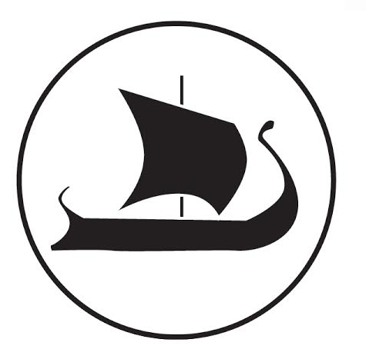 | Odysseus Journeys: 90 minute (or longer) immersive, creative, participatory experiences curated by a team of presenters.  The only human in this list of archetypes, Odysseus is renowned for his creative problem solving and leadership, and “odyssey” has become synonymous with a long and challenging journey.
These sessions take an experiential approach to problem solving through physical and/or mental exploration of the disciplines that contribute to a complex topic.

Examples and sources of inspiration for each type of presentation may be found at the conference website: http://ais2017.umbc.edu/program/

